**MULTI PURPOSE FINGERPRINT**

**LOCK**

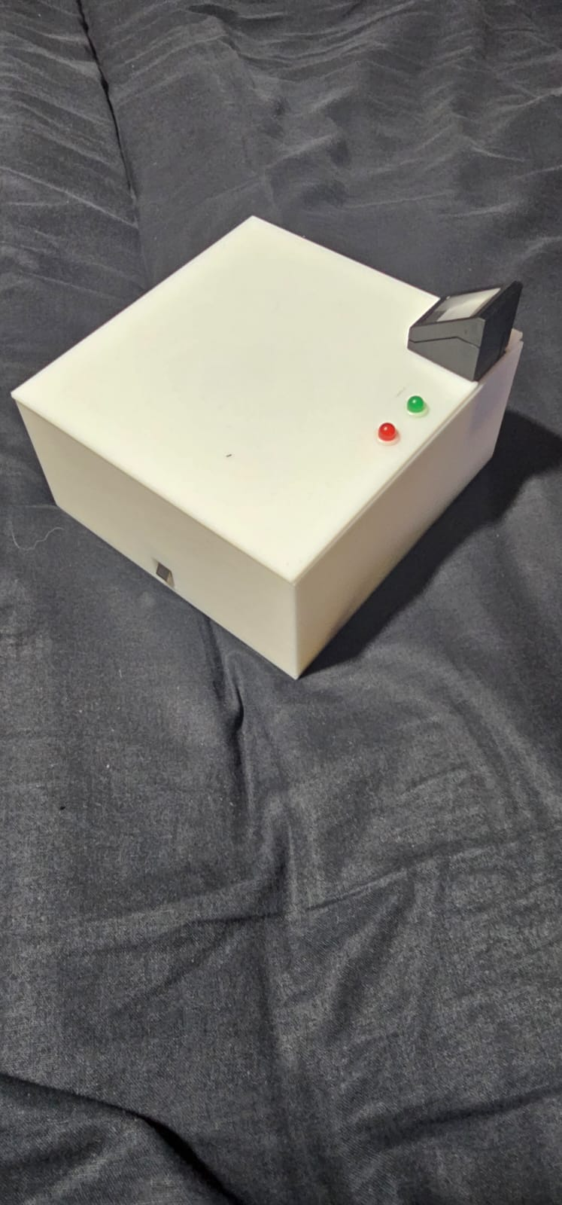

**Group 1**

**Hamza Afzal, M.Ahsan Asif, Cameron Jones, Alex Ainsworth**

Contents

Introduction: 3

Objectives/Problem: 3

Development: 3

Background Research: 3

Scope: 3

Theory: 3

Feasibility: 3

Development & Test and Evaluation of Prototype: 4

Equipment, Apparatus and Technique & Procedure 4

Design Phase 4

Hardware: 5

Software: 6

Testing: 7

Durability and Reliability Testing 7

Safety Testing 8

User Testing. 9

Conclusion: 10

Reflection: 10

Suggestion: 11

Manual: 11

# Introduction:

The purpose of this report is to document the development and evaluation of a multi-purpose fingerprint lock prototype, which was designed using an Arduino, fingerprint sensor, and a solenoid. The aim of the prototype is to provide a secure and convenient way to lock and unlock doors, safes, and other objects that require controlled access.

## Objectives/Problem:

The primary objective of the project was to design and develop a fingerprint lock that can be easily installed and configured to meet specific requirements. The project aimed to address the problem of unauthorized access to objects by providing a secure and reliable access control system.

Our goal was to design a fingerprint lock which is:

1. Cheap
2. Multi-purpose
3. Commercially feasible
4. Easy to use.
5. Secure

## Development:

The technique and procedure used for the development of the prototype involved the following steps:

1. Wiring the fingerprint sensor and solenoid to the Arduino board using PCB.
2. Installing the necessary libraries for the fingerprint sensor module and solenoid lock in the Arduino IDE software.
3. Programming the Arduino board to read fingerprints from the sensor and control the solenoid lock based on the authorized fingerprints.
4. Testing and debugging the prototype to ensure that it works as expected.
5. Creating a suitable case to hold the PCB and other components while making sure it is ready for commercial market.

# Background Research:

## Scope:

The scope of the project was to design and develop a prototype device that can be used for a variety of applications such as door locks, safe locks, and other objects that require controlled access. The prototype was designed to be easy to use, easy to install, and customizable to meet specific requirements.

## Theory:

The prototype was based on the theory of biometric authentication, which is a technology that uses unique physical or behavioural characteristics to verify the identity of an individual. The fingerprint sensor module used in the prototype is a type of biometric technology that scans and matches fingerprints to authorized users to provide secure access.

Research: Prior research on biometric authentication and fingerprint recognition was reviewed to determine the best practices for designing and developing a reliable and secure fingerprint lock prototype. The research focused on the different types of fingerprint sensors available, the algorithms used for fingerprint recognition, and the security risks associated with biometric authentication.

## Feasibility:

To justify the feasibility of the project, we will have to look at similar products. To do that we browsed Amazon and located products which are similar to ours and their application is similar to ours. Those products are available for sale, retail, ranging for 90-110 GBP. We made one single prototype under a budget of 100 GBP. If we are able to scale our product, we will have to buy components at wholesale rate which will reduce the cost. In addition to this, as R&D is not required for every product, that will also further reduce the cost.

*Price analysis*

# Development & Test and Evaluation of Prototype:

Equipment, Apparatus and Technique & Procedure: The prototype was developed using the following equipment and apparatus:

1. Arduino Nano board

Worked as the core of the project. Holds the flash memory which include the code and fingerprints and co-ordinates between all the components because of the microprocessor it has.

1. Fingerprint sensor module

It is connected to the Arduino to scan the fingerprint and the Arduino processes it and stores it into it’s flash memory.

1. Solenoid lock

The solenoid lock is connect to the relay and Arduino. Relay acts as switch which receives the signal from Arduino. The signal determines that if the lock is supposed to be open or not. In either case Relay responds in such a way that solenoid behaves according to what we want.

1. USB cable

It was used to flash the code onto the Arduino.

1. Computer with Arduino IDE software

We wrote the code in Arduino IDE software so we could flash it later to the Arduino.

1. Solidworks
   1. Used to design the casing of the project and get it 3d printed.

# Design Phase

The casing was designed in Solidworks. Solidworks is a pretty good tool to design any 3d Object. Further it gives us option to save the file in such formats that we can get it 3d printed.

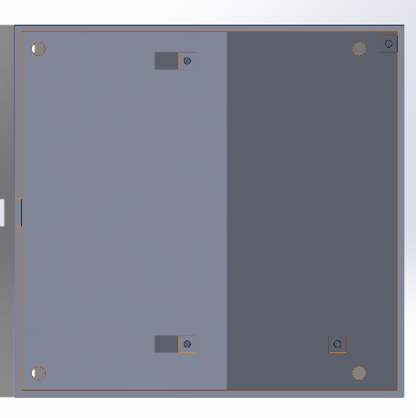

## Hardware:

Initially, we were able to demonstrate that our idea works. But the project was on breadboard. Usually that is the case with first prototypes, that they are on breadboard to show that it works because it is easier to change things as that is more of a test and improve approach.

We had ordered an external DC jack to power our project. So we would have different power source for solenoid as it draws 9V DC and a different power source for Arduino and other components. But we were able to figure out a way that we would only supply 9V to Arduino which in return would be able to power all the components.

Then when we had made sure that the project works, we changed the schematics. And we turned the schematics to a PCB. All our designing was done in EasyEDA. A technical part here was to make sure that the tracks which are going to be used for power are thicker than normal. Also we wanted to be on the safe side as well. The design of the PCB was as such that when we solder the components they are conveniently accessible. So placing the components at right place was really important. Furthermore, we had to design a lot of the components in EasyEDA as they weren’t available in the Library. Hence, this led to very accurate through holes in the PCB to solder components on.

When we tested the project, we were sure that we will only be using these parts. So we didn’t order any parts after that. This was also the plan because we discussed the components very thoroughly earlier in the R&D stage.

*Hardware Block Diagram*

*Circuit Schematic Diagram*

After thinking about the hardware we discussed what are the appropriate components we needed for this project. So for that we did a lot of research as we had to make sure we are in our budget. After doing our research and finding appropriate components we ordered the following components.

*Order Form*

## Software:

Our software’s algorithm is very straightforward. This helped us make the product work quicker. If we added more complexity, we were afraid that the response of the system might be slower. The current response time is about a second for registered fingerprints.

We have two parts of the code. First part is used to register the fingerprints. We can register up to 120 fingerprints. The code access’s the fingerprint module and it takes the picture of the fingerprint which is put onto it. The image is stored into the flash memory of the Arduino. This is the only part of the first code.

In the second code, the code access’s the fingerprint module. It takes the image of the fingerprint which on the module, it then compares that image with rest of the images stored in the memory. If the fingerprint is matched with any of the stored fingerprints. If it is the Arduino signals the Relay, which in return triggers the solenoid to an open state and changes the Led colour to Green. If the case is opposite, it does nothing, but keeps the Red Led on.

*Combined Flowchart of the Software*

# Testing:

The following procedure was used to test the prototype:

When the components came in, we got some faulty components as well. Which led us to check each component before we use that. For instance LED’s were supplied the required voltage individually through a power supply to make sure they are working and also making sure that they are not dim as we needed the perfect LED’s.

It is worth mentioning that we spent our budget not on 1 single quantity of each component, we ordered the parts in multiple quantities so that if anything goes wrong we are able to replace it except the Fingerprint sensor module and Arduino as they are expensive and for which we can get a work around. We got in multiple LED’s, Resistors and Solenoids according to the plan.

We used a multi meter which was provided by the university, to check voltage across the components and we made sure that they are only drawing enough current which is required to work. After that we made sure that all the components function properly. For instance, for fingerprint sensor we had to wait until the final code stage to check if it works. Although it did light up when the power was supplied but we still wanted to make sure that it read the fingerprint properly. Furthermore, we inspected the components visually, which came in help when the PCB’s arrived. There was a scratch on one of the PCB’s which would lead to a damaged track. So, we had to rule that PCB out and use another one as we had multiple PCB’s.

## Durability and Reliability Testing

For the durability testing of the product as we know most of the products were ordered and not made by ourselves, we were bound to follow the limitations set by the manufacturer. It is recommended that the product is used in an environment that has room temperature and moderately humid. But we worked out a range of from minus 5 degrees Celsius up to 45 degrees Celsius. This range also has been set up in such a way that the product will be safe to use in most of the case. This overall range has been worked out by considering the limits given to us by manufacturers. To prove that this range is perfectly fine we did put our product in the freezer for a - 5 degree test. And to test that it is fine to black in 45 degrees we used an oven. The test did go somewhat successful but at higher temperatures we know that usually the product do perform a little slower. But we think that if it is put into 45 degrees for a consistent amount of time the casing might get damaged. As the casing is 3D printed for prototyping purposes it might not cope with higher temperatures. The 3D printed cases depend on various factors. Like the amount of material we fill the object with. Hence that is what their prices and weight depends on. So we have to consider these factors when designing for commercial purposes.



*(ada, n.d.) Fingerprint Module Temperature Rating*

**

(Arduino, n.d.) *Arduino Nano Temperature rating*

**

(Farnell, n.d.) *Solenoid Temperature Rating*

Another important thing was the rejection rate and false acceptance rate of the fingerprint sensor.   
Rejection rate is the rate with which the fingerprint sensor rejects a correct fingerprint. That usually is 1 in 100 if the fingerprint is maintained well like being keep free of dust and debris. This was verified by doing the experiment practically. And it was successful and upto the mark.

False acceptance rate is when fingerprint opens the lock with unauthorized fingerprint or it matches X’s fingerprint with Y’s. That ratio is 0.001 in 100 which is given by the manufacturer. As far as we used the fingerprint we never came across such a scenario while we had this in mind.



(ada, n.d.) *Fingerprint Module FAR*

In the URS we were specified that the battery time should be at least 12 hours. But currently we are managing to get around 4 hours. Currently, we use a 9v non rechargeable battery. We haven’t connect it directly to the PCB so if the user want’s they can attach a rechargeable one to the connector.

## Safety Testing

Our product is a product which uses electricity. Hence the only harm could be user being exposed to electricity and the hazards which are driven by electricity e.g fire. We designed the product so that all the wires are contained inside the case further more there are no wires outside the case. We also checked for any short circuits in the PCB so that there is not fire in case of a short circuit. We made sure that all the connections do have enough solder and they are soldered properly in addition to this we made sure none of the solder is colliding with other soldered wire. We also had to make sure that none of the tracks are burnt while soldering or they are not damaged as a result of manufacturing fault because of which could also cause sparks later on subsequently leading to a fire.

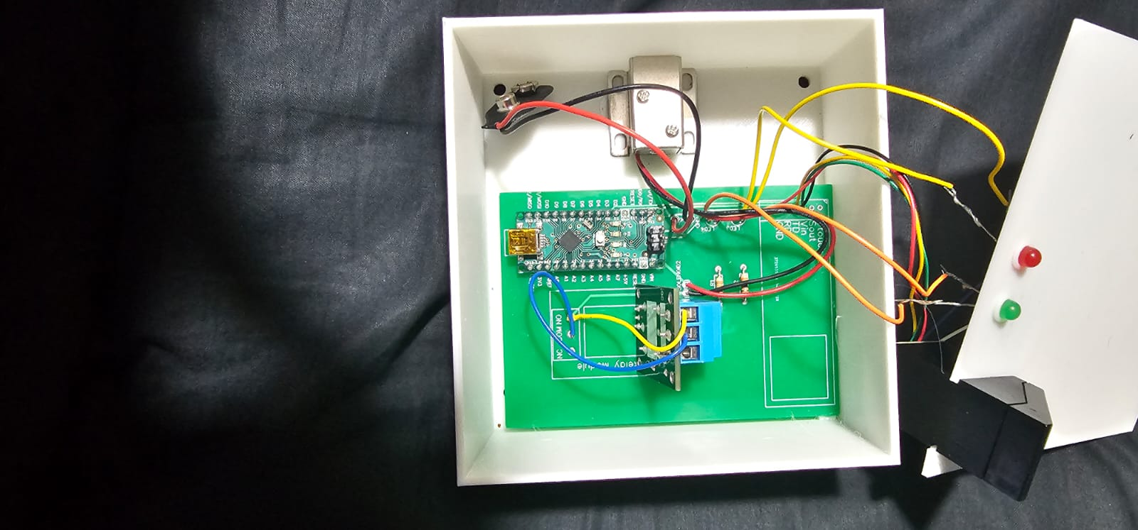

## User Testing.

Our product is designed completely from a consumer perspective. We were very conscious about the placement of components. Furthermore, we checked different position for fingerprint sensor, solenoid as well as LED to get the best possible position. This was a driving factor in the designing of the PCB as well as the 3D printed case. So the consumer of the product will be able to scan their fingerprint very easily as we have tucked the fingerprint module into the 3D case and made sure that it pops out. The reason that we wanted it to pop out was that the user should be able to scan their fingerprint properly. The current position of the fingerprint module made a 180 degree angle with the thumb or the finger of the user. And that was the best position determined after experimenting with the fingerprint module. In addition to this this was the position which gave us the best response from the system as we wanted the system to be quick enough to respond. If we scan the fingerprint in different position there was a high chance that the fingerprint won't be read properly.

Furthermore, the LED’s were put besides the fingerprint module because most of the times the user would be looking at the fingerprint sensor while scanning their finger or thumb. so while the user is looking at the fingerprint sensor when the fingerprint is scanned it would be shown on the green LED and it would give the user instant information that the lock is now open. So we had to also consider the psychology of the user. Another factor into designing our product was choosing the colour white. As we know that white colour absorbs less light hence it doesn't get heated that quickly. This was a drive from our side to make sure that we could be able to maintain the temperature of a running product as low as possible.

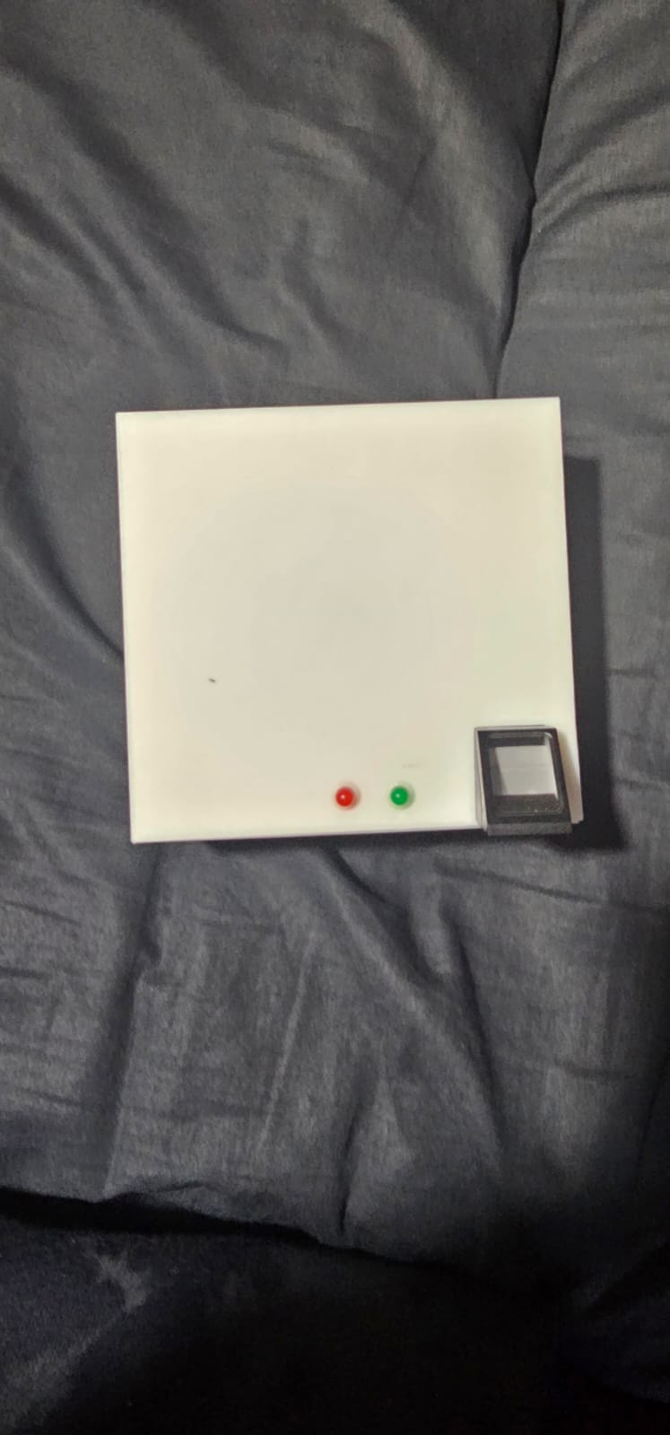

This testing was done by design and test approach because we wanted to initially design and think what we could improve over by testing the final model.

# Conclusion:

We were able to achieve the following outcomes from the project as in alignment with our interim report:

The prototype was successfully developed and tested, and the following results were obtained:

The fingerprint sensor module was able to accurately read and match fingerprints to authorized users.

The solenoid lock was able to lock and unlock object based on the authorized fingerprints.

The prototype was able to store multiple fingerprints and provide access to authorized users quickly and reliably.

Based on the results obtained, it can be concluded that the prototype is a reliable and secure way to control access to objects

## Reflection:

In our opinion our project could have been much better if the external factors didn’t matter as much.

First case is about the components. The deadline for to submit the order forms was before Christmas holidays which was met perfectly. But despite that we didn’t get our components on time as they were ordered after the Christmas holidays by the university. But we were able to produce a working prototype on a breadboard as it is much more feasible because of less Research and Development involved to develop a PCB. This was all done while meeting the deadline.

In another scenario for example, the PCB. We had guidelines to order the PCB through the university. But the PCB didn’t arrive until 2 days before we were supposed to present the final prototype. Although we had sent out the Gerber files just after we displayed our first prototype. Hence, we had very little time to implement the improvements we had thought about and ultimately the product was not somewhat we wanted. This all happened despite us meeting all our deadlines.

Furthermore we had lots of options which we could improve, for example one of the options was to decrease the on time for the red LED as it's usually on. We weren't able to do so because of the time constraints we had although this is a purely software based solution and this would also help us increase the battery time of the system. In addition to this one more change we wanted to do was that we wanted the system to be dependent on a lithium ion battery which are usually rechargeable. This would give the system the liberty of being remote which is specified in the URS but if we went for a DC Jack which means that the DC power is directly supplied from a outlet this would decrease the mobility of the system as they would need a socket to be beside or somewhere near the system.

If we were do add these things in the project I think the project would have been perfect considering the URS.

## Suggestion:

We met all our deadlines and completed the product we planned. But still in our opinion, it would have been much better that if we were authorized to order PCB’s and components. That would give us a much better grip on the project as we would be able to plan ahead of schedule.

# Manual:

1. ***Introduction***

The multipurpose fingerprint sensor lock is a versatile security device that can be used to secure a wide range of items such as lockers, cabinets, and safes. It is equipped with advanced biometric technology that provides reliable and accurate identification of your fingerprints.

1. ***Installation***

The installation process for the multipurpose fingerprint sensor lock will vary depending on the item you are securing. However, the basic steps are as follows:

Step 1: Prepare the item - Before installing the lock, ensure that the item is clean and free from any dust or debris. Remove any existing locks or hardware that may interfere with the installation.

Step 2: Install the lock - Align the lock with the hole on the item and insert the lock cylinder into the hole. Use the provided screws or adhesive tape to secure the lock in place.

Step 3: Install the battery - The lock is powered by 9V batteries. Open the compartment and insert the batteries according to the polarity markings.

Step 4: Register fingerprints - Follow the instructions provided to register your fingerprints. The lock can store up to 120 fingerprints.

1. ***Usage***

Once the installation is complete and your fingerprints are registered, you can begin using the multipurpose fingerprint sensor lock. To unlock the item, simply place your finger on the sensor. The lock will quickly scan and verify your fingerprint before unlocking the item.

1. ***Maintenance***

To ensure that the multipurpose fingerprint sensor lock continues to operate smoothly, it is important to perform regular maintenance. This includes:

* Keep the lock clean and free from dust and debris.
* Replace the batteries when they run out of power.
* Test the lock regularly to ensure that it is working correctly.

1. ***Troubleshooting***

If you experience any issues with your multipurpose fingerprint sensor lock, please refer to the troubleshooting guide provided with the lock. Common issues include:

* The lock fails to recognize your fingerprint.
* The lock does not respond to input.
* The lock makes unusual sounds.

If you are unable to resolve the issue, please contact the manufacturer for assistance.

1. ***Conclusion***

The multipurpose fingerprint sensor lock is a reliable and versatile security device that provides advanced protection for your valuable items. With proper installation, usage, and maintenance, you can enjoy many years of trouble-free operation.